Username - Shail

Password - Shailpatel86$

<https://dev106.signin.aws.amazon.com/console>

Go to the above link and log in with the given credentials

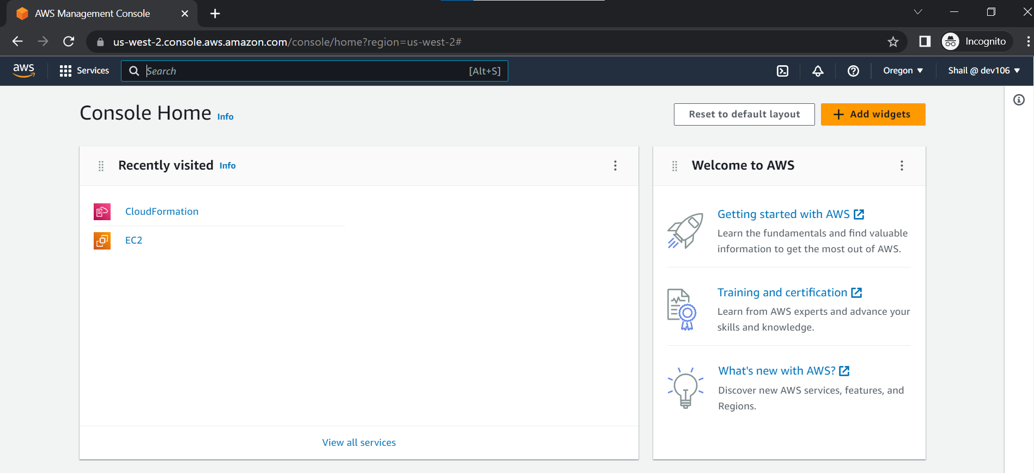

Click on EC2

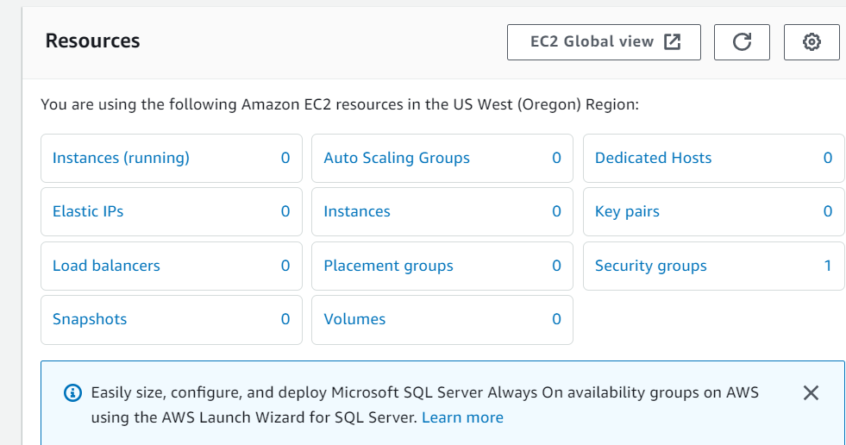

Click on Instances

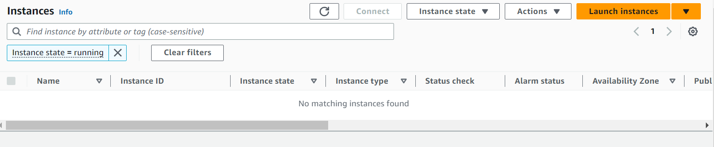

Click on launch instance

Give a name to your instance, create a keypair and keep the rest of the configurations to default and click on launch instance.

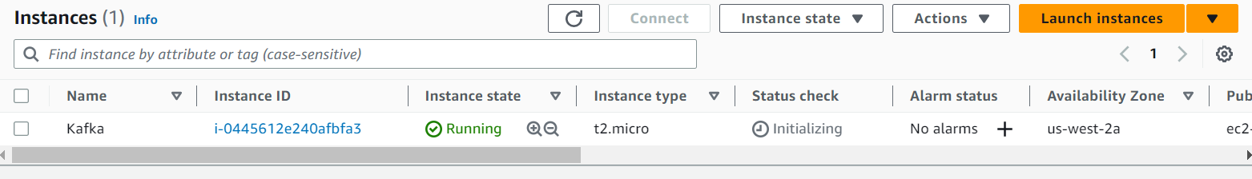

Click on the instance id

Click on connect

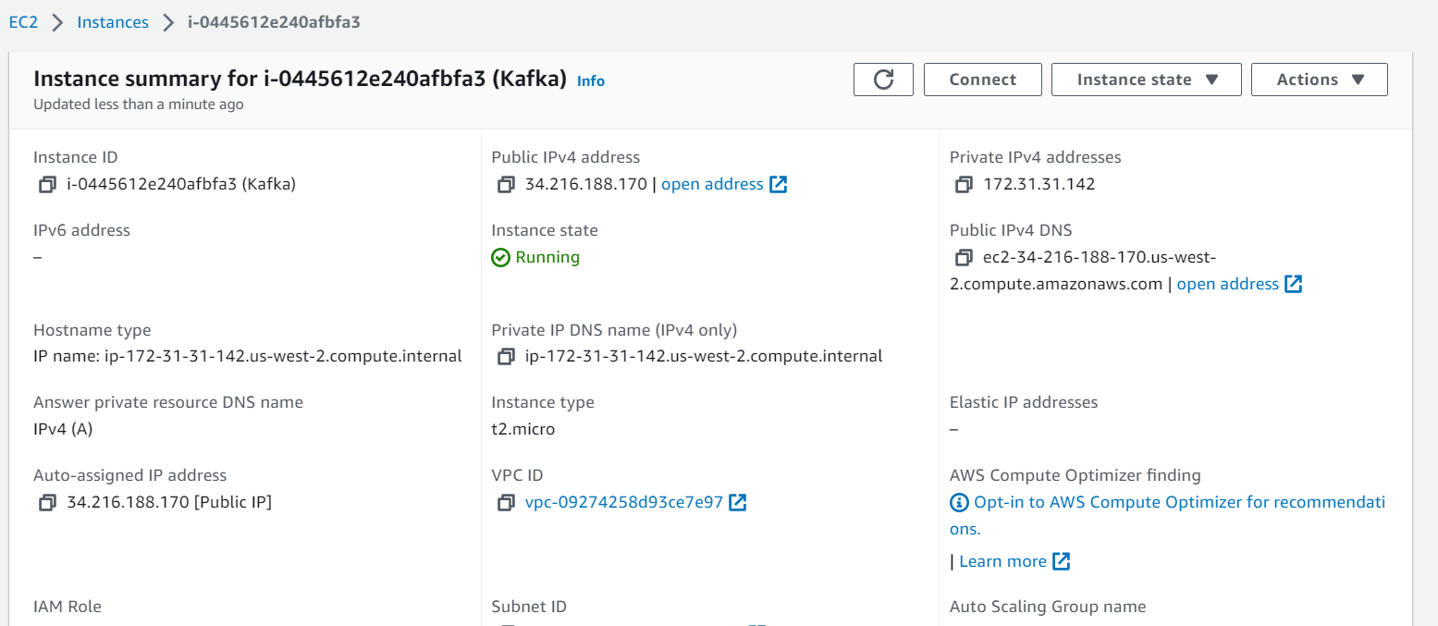

We will run the following commands on our instance to setup kafka and zookeeper

We get https://archive.apache.org/dist/kafka/3.3.1/kafka_2.12-3.3.1.tgz

tar -xvf kafka_2.12-3.3.1.tgz

-----------------------------------------------------------------------

java -version

sudo yum install java-1.8.0-openjdk

java -version

cd kafka_2.12-3.3.1

# for ubuntu -

sudo apt-get update

sudo apt-get install -y openjdk-8-jdk

java -version

cd kafka_2.12-3.3.1

------------------------------------------------------------------------

Start Zoo-keeper:

bin/zookeeper-server-start.sh config/zookeeper.properties

-----------------------------------------------------------------------

Start Kafka-server:

Duplicate the session & enter in a new console --

export KAFKA_HEAP_OPTS="-Xmx256M -Xms128M"

cd kafka_2.12-3.3.1

bin/kafka-server-start.sh config/server.properties

It is pointing to private server , change server.properties so that it can run in public IP

To do this , you can follow any of the 2 approaches shared belwo --

Do a "sudo nano config/server.properties" - change ADVERTISED_LISTENERS to public ip of the EC2 instance

--------------------------------------------------------------------------------------------------------------

Create the topic:

Duplicate the session & enter in a new console --

cd kafka_2.12-3.3.1

bin/kafka-topics.sh --create --topic demo_testing2 --bootstrap-server 54.215.179.39:9092 --replication-factor 1 --partitions 1

------------------------------------------------------------------------------------------------------------

Start Producer:

bin/kafka-console-producer.sh --topic demo_testing2 --bootstrap-server 54.215.179.39:9092

----------------------------------------------------------------------------------------------------------------

Start Consumer:

Duplicate the session & enter in a new console --

cd kafka_2.12-3.3.1

bin/kafka-console-consumer.sh --topic demo_testing2 --bootstrap-server 54.215.179.39:9092

--------------------------------------------------------------------------------------------------------------

In Databricks create a ckuster and install this library on the cluster

kafka-python

Attach the cluster to both the notebooks, change the IP to the current instance's IP and run the notebook.

----------------------------------------------------------------------------------------------------------------

After the kafka cluster is setup on the instance, we will go to our Databricks notebooks and setup kafka consumer and kafka producer

Go to compute and click on create compute to set up a cluster

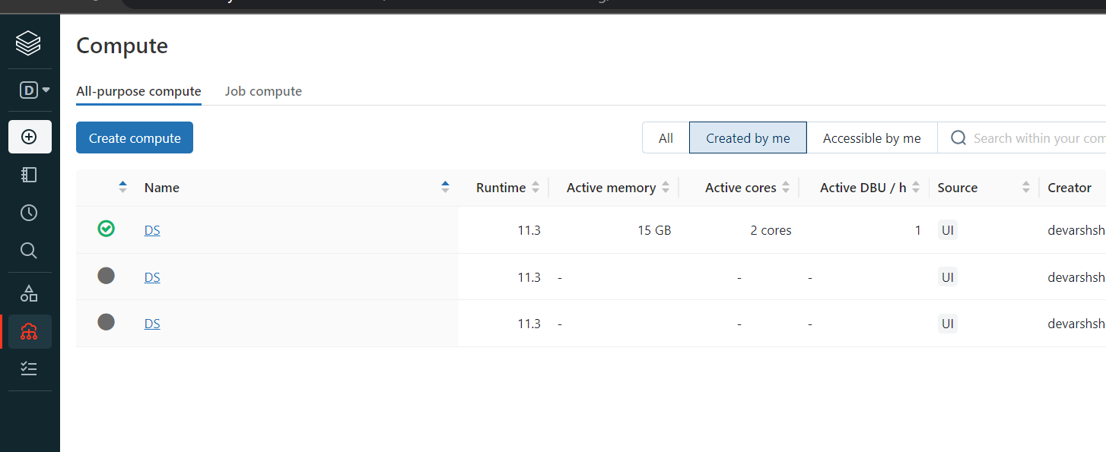

Click on the cluster name and go to libraries

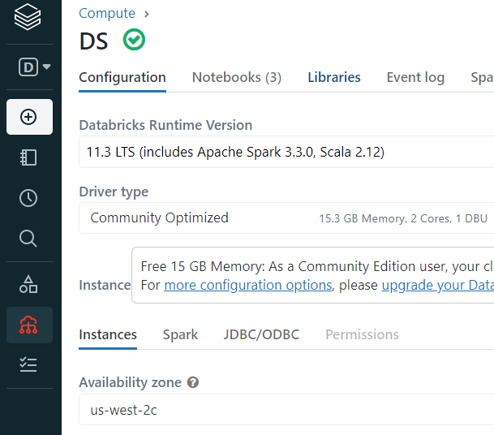

Inside it click on Install new

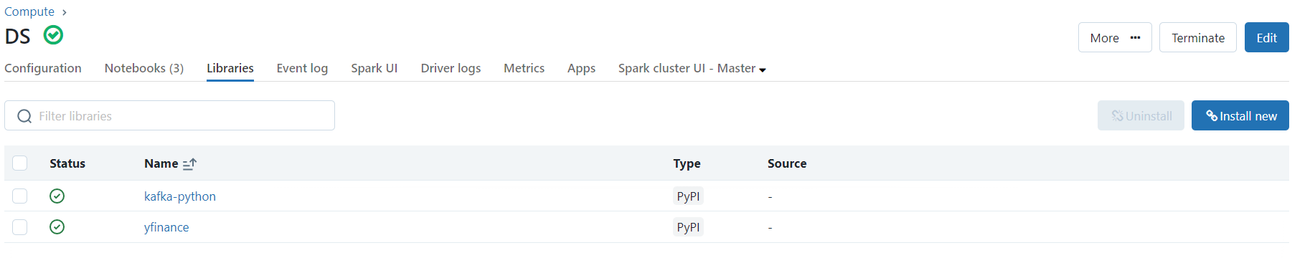

Select pypi and install two libraries one by one, kafka-python and yfinance

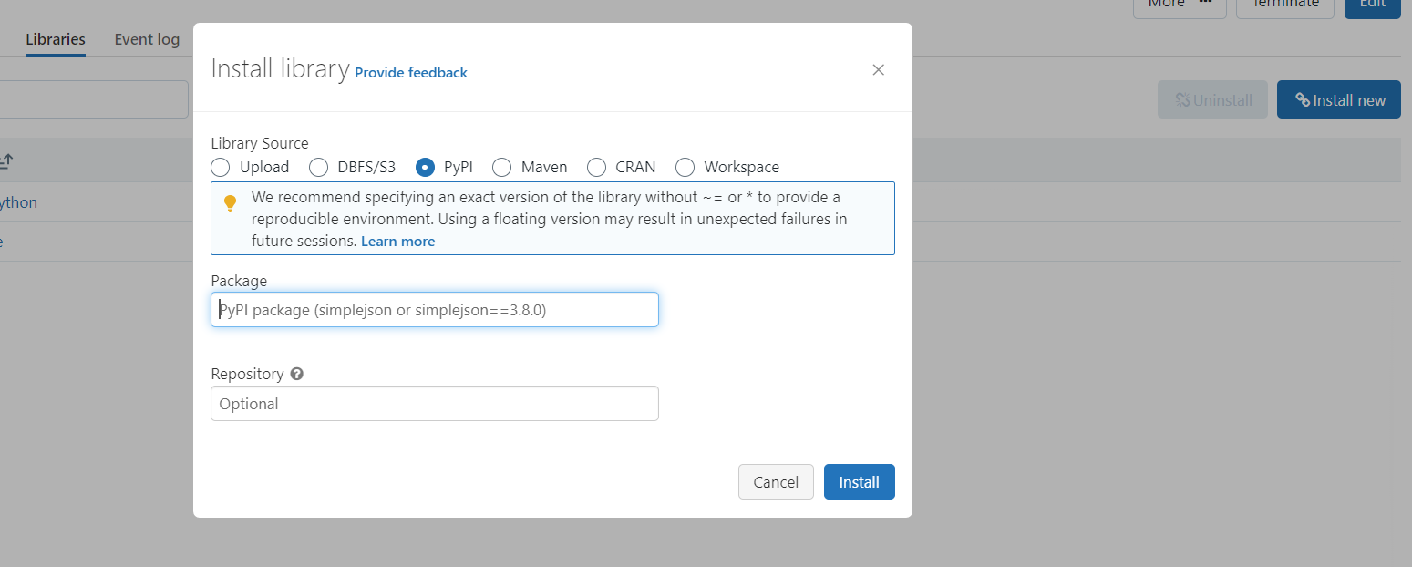

Go to kafka producer notebook and click on run all

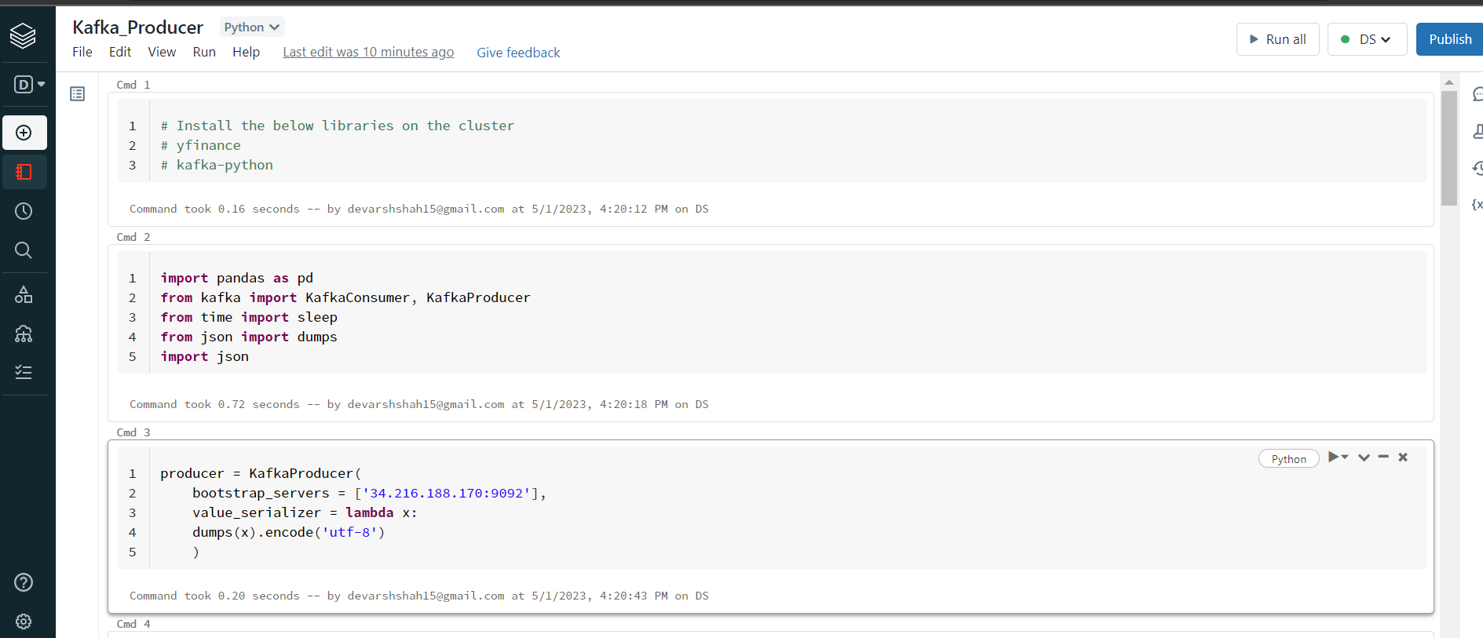

Go to kafka consumer notebook and click run all

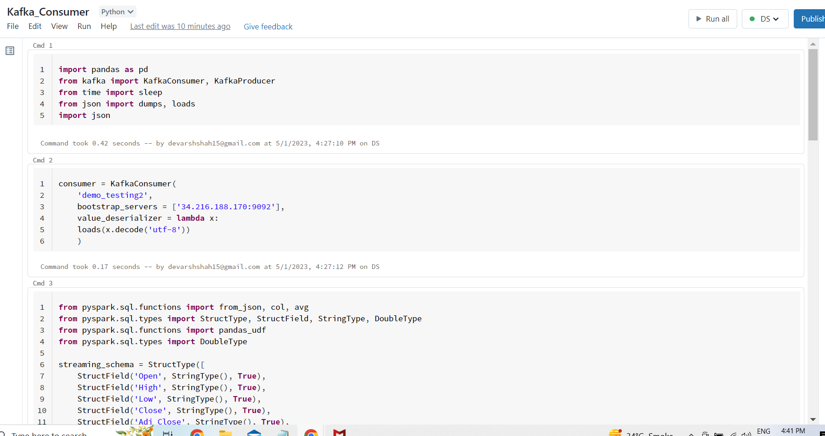

You will start seeing the values in the stream

